Utica Public Library

Summer Reading Program 2024

……June 10 - July 20……

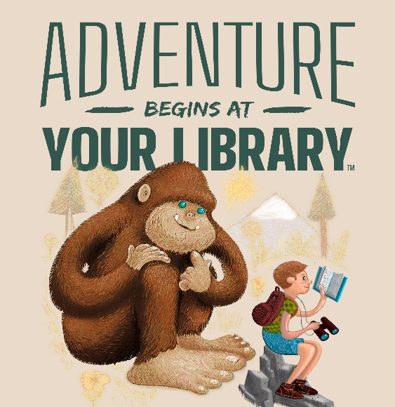

**Keep your brain active this summer by registering for Utica Public Library’s Summer Reading Program. Participants of all ages get the chance to *earn prizes when they read from June 10 through July 20.* Stretch your reading muscles and reach your goal!**

**Important DATES**

* **June 3:** Registration begins
* **June 8:** **SRP Kick-Off** -**Bubbleman, Bounce House, craft and fun lawn games at** **1 p.m.**
* **June 10:** Summer Reading begins
* **June 12th:** **The Reptarium** show at 1 p.m. ***registration Required; Seating limited.***
* **June 19th:** **Downtown Utica Scavenger Hunt**
* **June 25th: TechKnowkids –** Camping STEAM at 2 p.m**. *registration Required, Seating limited.***
* **July 4th - 6th:** Library closed
* **July 17th: TechKnowkids –** Summer Adventures! at 2 p.m. ***registration Required; Seating limited.***
* **July 20th:** **Ming the Magnificent Magic Show at 1 p.m.** Last day of summer reading, last day to turn in reading materials. ***registration Required; Seating limited.***

**How to PARTICIPATE**

* Register for summer reading by coming into the library.
* Registration begins June 3rd
* For every **6 books** read for children 0-2nd grade and **100 minutes** for grades 3 and up, fill out reading logs and visit the library for a prize and fill out an entry ticket to be entered into the weekly and Grand Prize drawings.
* Complete **Adventure Bingo activity sheet** for a prize
* Attend *free* events throughout the summer to earn entry tickets for grand prizes
* Return reading records and activity sheets weekly to the library to get stamped from **June 10 – July 20**

**\*\* YOU MUST BE ENROLLED IN THE SUMMER READING PROGRAM TO BE ELIGIBLE FOR AWARDS AND PRIZES**



**\*Check the Utica Library website or Facebook page to get more information on events and times/dates for programs** [**www.uticalibrary.com**](http://www.uticalibrary.com) **or @uticapublib**

**THANK YOU** to this year’s sponsors:

Dave & Busters * Dairy Queen * Sam’s Sorrento Pizza

USA Tire * USPBL Jimmy John’s Field * Dolan Optical * MOD Pizza * Zap Zone